Launch of the Consultation Forum Third Phase

Bucharest - 12 June, 2019

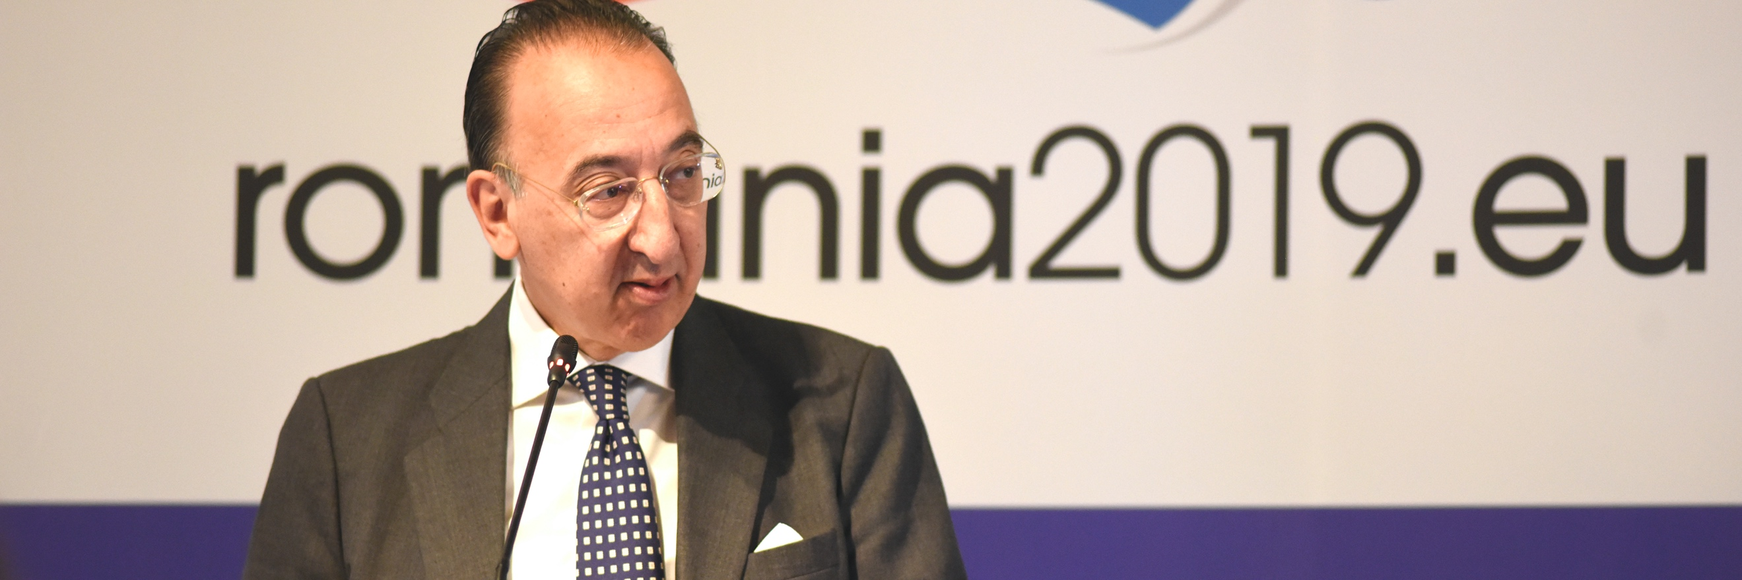

**Jorge Domecq, EDA Chief Executive and Dominique Ristori, European Commission Director-General for Energy announced today in the presence of Mr Gabriel-Beniamin Leș, Minister of National Defence of Romania the initiation of the Third Phase of the Consultation Forum for Sustainable Energy in the Defence and Security Sector (CF SEDSS III).**

The announcement was made in the margins of the 4th CF SEDSS II Conference which is held under the Romanian Presidency of the Council of the European Union and hosted by the Romanian Ministry of National Defence.

The EDA Chief Executive emphasised that *“the Agency’s interest in energy has been increasing in the last years, primarily because the Ministries of Defence have identified the importance of this topic, and because of how energy affects and will change our life in the future”*. As he pointed out, *“disruptive technologies and new business models are reshaping the energy ecosystem and the defence sector needs to be part of this”*. New trends such as digitalisation, electrification, innovative energy technologies in battery storage, smart buildings, electric vehicles, artificial intelligence, integrated energy management systems as well as unknown malicious and hybrid threats require the defence sector not only to adapt to the fast-paced changing security environment but also to be able to recover when compromised.

Mr Ristori remarked that*“all strands of the EU’s energy policy -energy efficiency, renewables, security of supply, interconnections- have an impact on our common European defence. That is why I believe the start of Phase III is an important step forward which reaffirms the Commission’s strong commitment to address our common energy challenges in close cooperation with the European Defence Agency”*. He also said that *“by improving the way the defence and security sector uses energy, new real economic opportunities can arise, creating jobs and growth for all Europeans”*.

Phase III will continue pursuing the implementation of the EU legal framework on energy and will reaffirm the Consultation Forum as the appropriate vehicle to share best practice, information and experiences among the EU Ministries of Defence. With the support of the European Commission the Forum will bring closer the defence and energy communities with a view to improving energy efficiency, the use of renewable energy sources, and the protection of defence energy-related critical infrastructures.

Building on the know-how of the previous Phases and with the aim of adapting to future energy dynamics, Phase III will foresee the creation of a new ad-hoc transversal working group, which will cover the thematic activities on energy management and finance as well as a novel category on state-of-the-art technologies affecting the energy-defence dimension.

Phase III is expected to enable economic, operational and strategic results within the context of project ideas, guidelines, and action plans that can assist Ministries of Defence to apply more affordable, resilient, and sustainable energy models at the national level. To address such objectives, the Agency will implement several multi-dimensional activities ranging from high-level conferences and thematic workshops to table-top exercises.

Phase III will also be underpinned by the organisation of Energy Technology Solutions events engaging the civil sector, the industry and academia to ensure that the Forum keeps pace with the leading-edge developments in energy.

With the support of the European Commission’s Directorate-General for Energy and the collaboration of the members of the Forum, the Agency will focus its work on how to better support Ministries of Defence to enhance strategic autonomy and resilience through a diversity of options within the nexus of the European Energy eco-system including the European defence dimension.